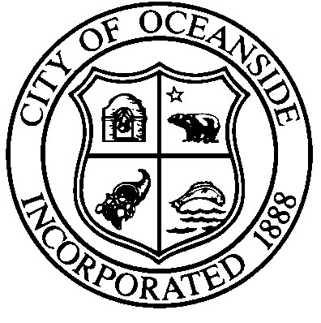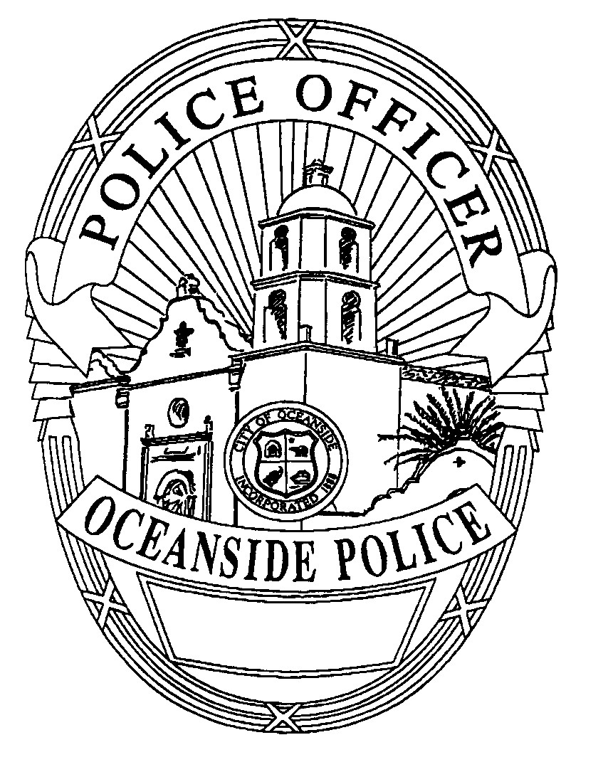

OCEANSIDE POLICE DEPARTMENT

NEWS RELEASE

Contact:

Heather Mitchell,Public Information Officer For Immediate Release (760) 435-4672 (Desk)
Email address: HMitchell@oceansideca.org
August 19, 2024

Oceanside Police Investigate Random Assaults at the Oceanside Harbor

On Saturday, August 17, 2024, at approximately 8:50 PM, the Oceanside Police Department received reports of a violent altercation involving several suspects at 1400 N. Harbor Drive. According to witness accounts, two individuals, identified by bandanas covering their faces, were seen assaulting several men with baseball bats. Before officers arrived, the suspects fled the scene in a vehicle. Upon arrival, officers discovered two victims suffering from head trauma. The Oceanside Fire Department promptly transported both victims to the hospital for emergency medical care. Witnesses at the scene stated that the suspects appeared to be instigating fights with random passersby. A bystander, who began recording the incident on her phone, was subsequently targeted by the suspects who attempted to seize her device.

Shortly after the initial report, the Oceanside Police Department received additional information about two other victims who were being treated for similar injuries at Tri-City Medical Center (TCMC). Although unrelated to the two other victims, they were assaulted in the same area and manner by the same suspects. All victims sustained significant injuries, including head lacerations and one with a facial fracture.

The Oceanside Police Department is actively investigating this incident and has located the suspect vehicle and possible suspect information.

Oceanside Police Department’s Crimes of Violence Unit is asking anyone with information regarding this incident to please contact Detective Sergeant Dave Estrada at (760) 435-4698 or email DEstrada@oceansideca.org.

###

